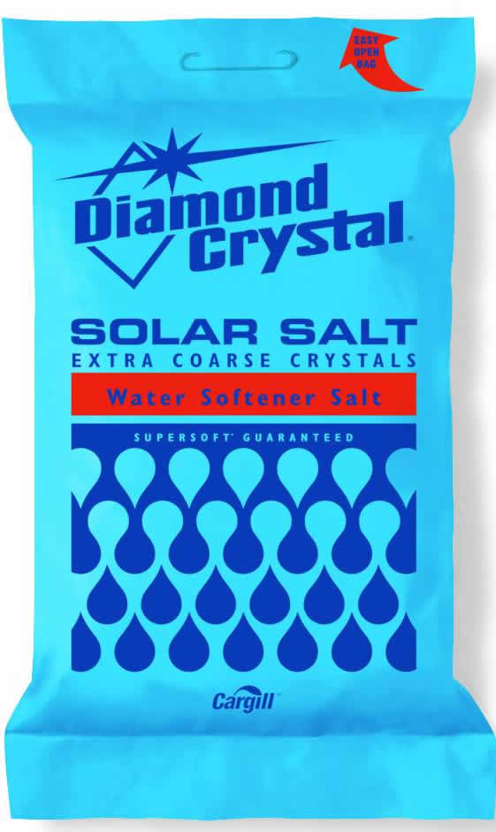
Softener Salt: Solar Salt

- Works in all water softeners
- Extra Course Solar Salt
- 40 Lbs.
#46

$4.49
X0100020

